**Lab 6**

**Timers**



**Spring 2025**

Submitted by: **Mohsin Sajjad**

Registration No: **22pwsce2149**

Class Section: **A**

“On my honor, as student of University of Engineering and Technology, I have neither given nor received unauthorized assistance on this academic work.”



Student Signature: ______________

Submitted to:

**Engr. Faheem Jan**

Month Day, Year (23 03, 2025)

Department of Computer Systems Engineering

University of Engineering and Technology, Peshawar

**Timers**

* Timer use to generate a delay
* Event counter to count events happening outside the microcontroller

**TASKS:**

**Task 01:**

Create a delay of 2.5 sec .. the LED should ON after 2.5 sec and OFF for 2.5 seconds.

**CODE:**

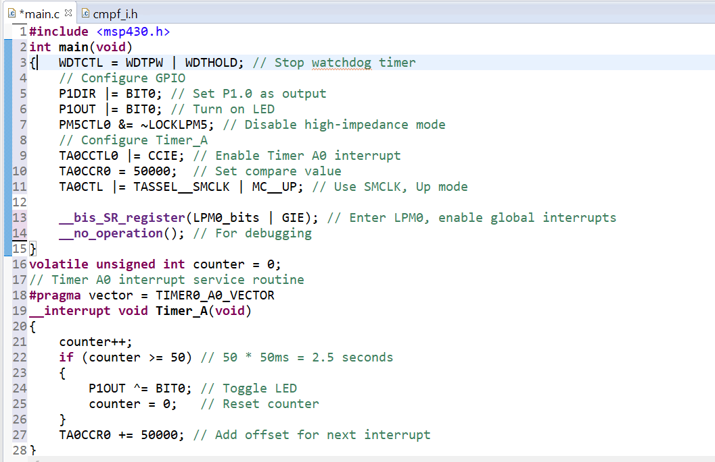

**OUTPUT:**

**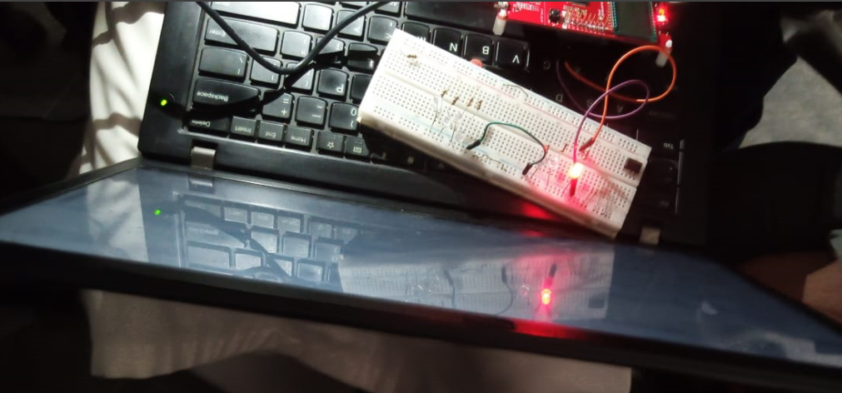  
conclusion:**

This code uses Timer_A on the MSP430 to toggle an LED (P1.0) every 2.5 seconds using an interrupt-based approach. The timer generates an interrupt every 50ms, and after 50 counts, it toggles the LED state. This ensures efficient power usage by running in low-power mode (LPM0) while maintaining precise timing.

**Task 2:**

Create a delay of 1 sec .. the LED should ON after 1 sec and OFF for 1 sec …

**CODE:**  
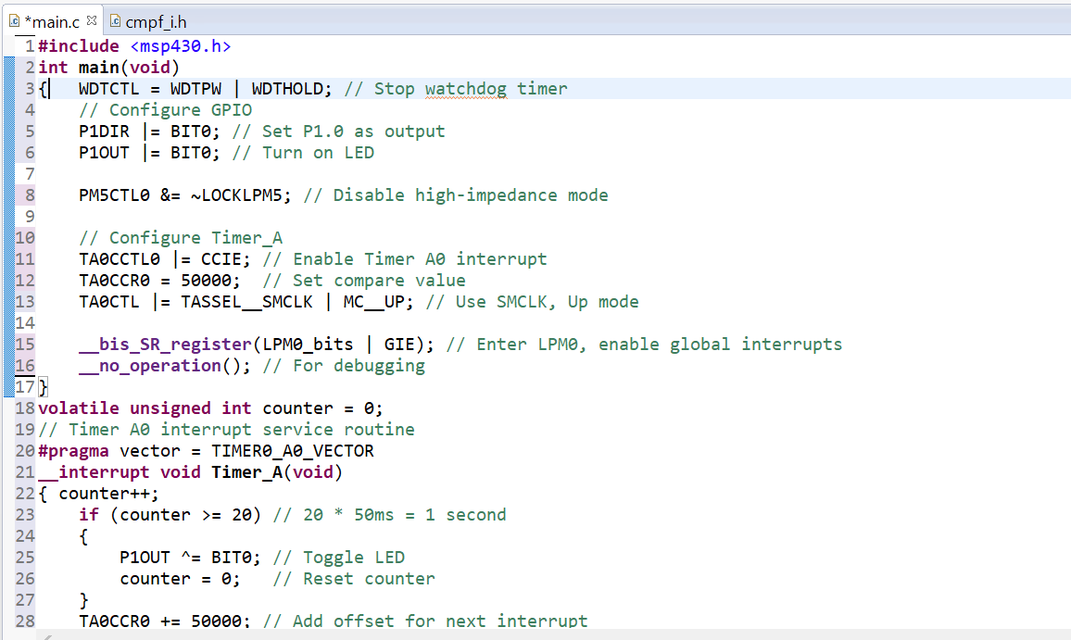

**OUTPUT:**

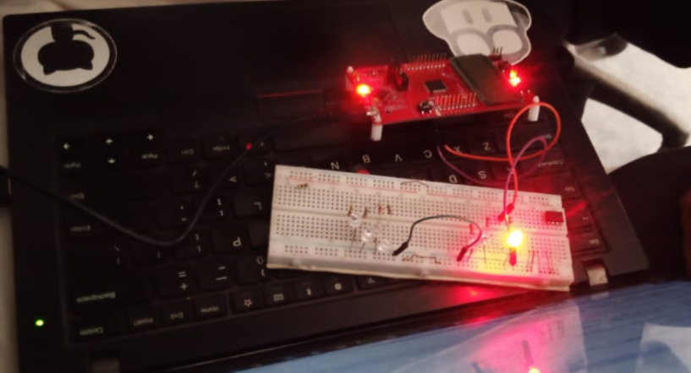

**CONCLUSION:**

This MSP430 program uses Timer_A to toggle an LED (P1.0) every 1 second using an interrupt-based approach. The timer triggers an interrupt every 50ms, and after 20 counts, it toggles the LED. The low-power mode (LPM0) ensures efficient power consumption while maintaining accurate timing.

**TASK 03:**

Create a delay of 500 msec .. the LED should ON after 500 msec and OFF for 500 msec …

**CODE:**

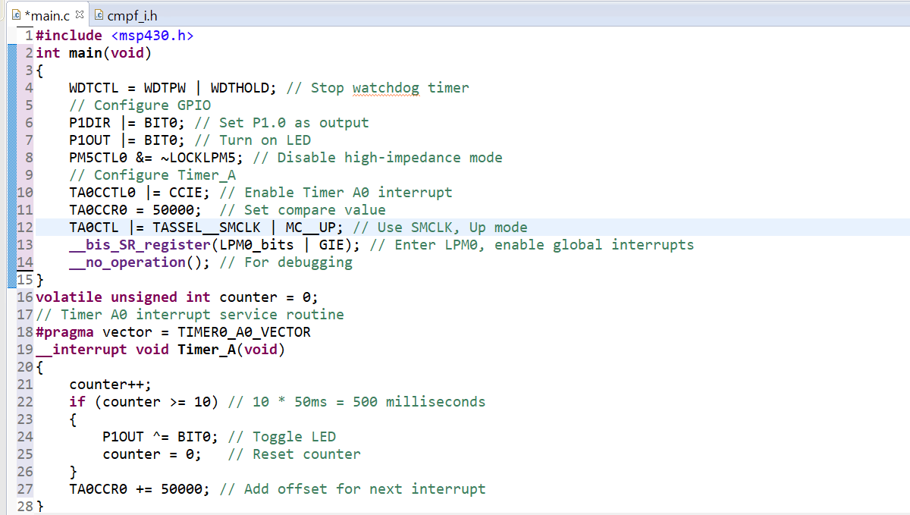

**OUTPUT:**

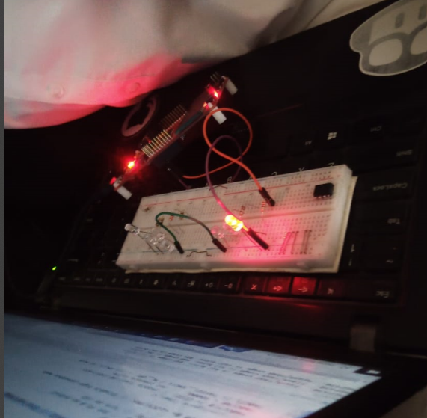

**CONCLUSION:**

This MSP430 program uses Timer_A to toggle an LED (P1.0) every 500ms with an interrupt-based approach. The timer fires an interrupt every 50ms, and after 10 counts, the LED toggles. The low-power mode (LPM0) optimizes power consumption while maintaining accurate timing.